Ant Esports 100 Air Mini Gaming Cabinet

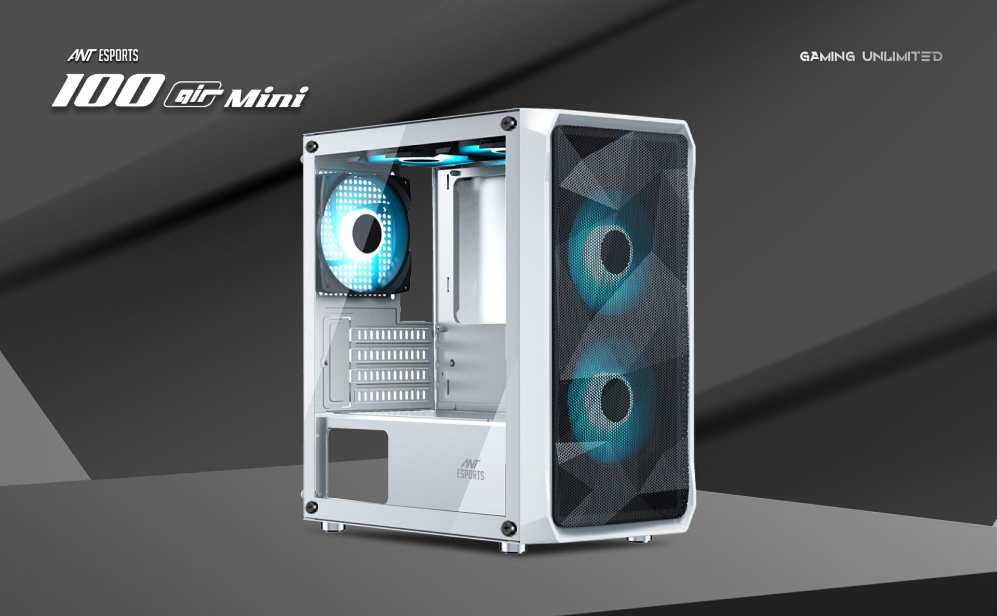

Ant Esports 100 Air Mini is designed to cater to the needs of avid gamers and enthusiasts, this compact powerhouse offers a stunning blend of form and function. Supporting up to mATX motherboards, the 100 Air Mini is a versatile choice for creating a powerful gaming rig. Unleash the full potential of your components with the capability to accommodate up to seven 120mm fans, including two strategically positioned on the PSU shroud to provide direct air cooling to your graphics card.Efficiency meets style with the 100 Air Mini's generous allowances for cooling solutions. Experience top-notch cooling performance as you explore the potential of CPU Air Coolers up to 160mm in height and graphics cards up to 340mm in length. Dive into the realm of liquid cooling with support for radiators up to 240mm, ensuring your system stays cool even during the most demanding gaming sessions.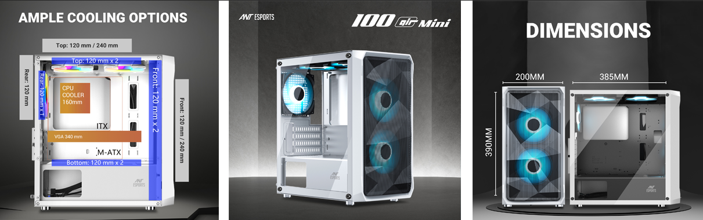Storage is a breeze with the 100 Air Mini, as it effortlessly accommodates two 3.5" HDDs and one single 2.5" SSD, ensuring you have ample space for all your games, files, and media. Crafted with both functionality and aesthetics in mind, this gaming cabinet boasts a sleek and modern design that will elevate any gaming setup.Elevate your gaming experience and build your dream rig with the Ant Esports 100 Air Mini PC cabinet. Unleash the power, keep your components cool, and revel in a design that's as sleek as it is functional.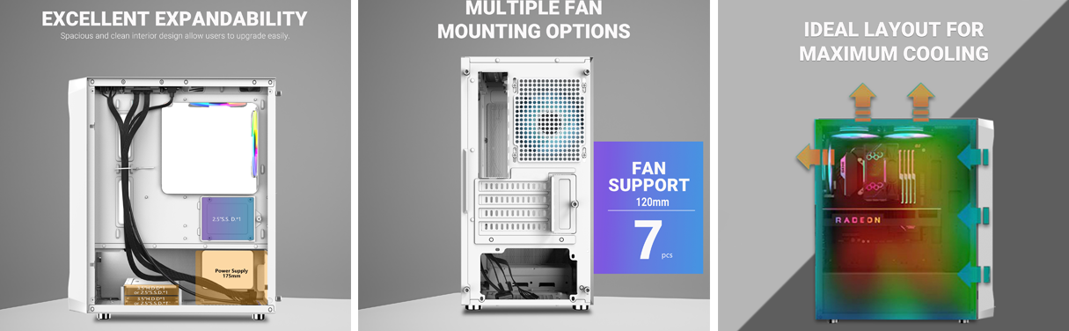

* + **Compact yet Powerful Design:** The Ant Esports 100 Air Mini is a compact gaming PC cabinet designed to pack a punch. Its compact form factor is perfect for space-conscious setups, while still providing ample room for high-performance components.
  + **Efficient Cooling System:** With support for up to seven 120mm fans, including two strategically placed on the PSU shroud for direct air intake to cool the graphics card, the 100 ensures optimal airflow. This cooling setup helps maintain stable temperatures even during intense gaming sessions.
  + **Versatile Component Compatibility:** The cabinet supports mATX motherboards, allowing gamers to build a powerful system within a smaller footprint. It can accommodate CPU air coolers up to 160mm in height, ensuring compatibility with a wide range of cooling solutions for efficient heat dissipation.
  + **Graphics Card and Storage Flexibility:** Gamers can enjoy the freedom to install graphics cards of up to 340mm in length, making it possible to harness the power of high-end GPUs for a superior gaming experience. Additionally, the cabinet offers storage versatility, accommodating two 3.5" HDDs and one 2.5" SSD, ensuring ample space for games, media, and other data.
  + **Liquid Cooling Ready:** The 100 is also liquid cooling ready, supporting radiators of up to 240mm in size. This option allows enthusiasts to take advantage of advanced cooling solutions, providing efficient heat dissipation and further enhancing system performance.

